Business Plan

Flame Guard

**Team:** Blaze Battalion

# Team

Brent Duncan - CEO

Sarita Aryal -CMO

Michael Le -CTO

Abhisek Kumar Shandilya - CFO(Leader)

Index**:**

Team 2

Index 3

Summary 4

Scenario 4

Issue and problem 5

Market 5

Lean Canvas 7

Tech/Product demo 8

Solution 8

AWS Services 8

Issue 8

Unique Value Proposition 8

Finances 8

Customer Experience Report 8

Customer Profile 8

Problem Statement 8

Solution Implemented 8

Customer Experience 8

Overall Satisfaction 8

References 8

# Summary

Flame Guard combines cutting-edge infrared (IR) cameras with cloud services for early fire detection. The system’s IR cameras monitor temperature changes, alerting users to potential fires before smoke or flames appear. Key features include cloud integration, false alarm prevention, and precise thermography. Targeting farms, commercial buildings and critical infrastructure, Flame Guard offers a subscription-based and one time hardware-based service. Pilot deployments, marketing efforts, and strategic partnerships will drive adoption. Profit margins and competitive pricing ensure sustainability.

# Scenario

Imagine yourself as a farmer living out in a rural area of the Australian bushland. Scenic plains and beautiful trees as far as your eyes can see. You have a handful of neighboring households, each over a kilometer away from you. But you know all your Neighbour's names. Imagine yourself tending to crop and livestock to support yourself and your family. This is the peaceful life you have made for yourself, the life you want to maintain until you retire.

Now imagine the fear and anxiety of knowing it can all be lost in a moment. Imagine waking up and hearing that a fire is approaching your farm and having to evacuate your home. As you leave, you worry this is the last time you will see your home. You worry about your way of life, and your livelihood will be destroyed. This is the reality for thousands of families living in bushfire-prone regions in Australia.

# Issue and problem

Rural Australian towns are frequently ravaged by bushfires causing damage to property, farmland, livestock, and loss of life. During the bushfire season of 2019-2020, it was estimated that 3094 homes were destroyed. There is also widespread damage to natural ecosystems resulting in mass loss of life and homes for many of Australia’s iconic wildlife. There are not only short-term consequences to these fires but also dangerous long-term consequences. Research has shown that in the aftermath of a fire, ash and burnt material can enter water systems and damage the aquatic life and the quality of water many rely on for drinking and agriculture.

There has been a constant search for more rapid and accurate early detection systems. These are valuable to warn people about fires to help them evacuate their homes, preventing loss of life. It is also helpful to firefighters as the sooner a fire is detected, the sooner it can be brought under control.

The most recent innovation for this was using satellites to assist with detection. While there are many benefits to this solution, it also has several flaws. Geostationary satellites are satellites that stay over the top of one area. While these would be best for reliability as it is always in place to gather information, these satellites have several flaws. Firstly, the primary satellite used for this purpose is Japan's Himawari-9, which only takes one photo every 10 minutes. That same satellite produces pictures where one pixel represents 1km2 of area, meaning bushfires cannot be seen until they have reached a significant size. These are due to geostationary satellites requiring an extremely high orbit to maintain their position. Lower satellites have their own set of issues, mainly that these satellites can only see bushfire-prone areas during irregular intervals. This means the quality of coverage can vary based on how many satellites are available at any given time. The need for a more reliable and fast system for detection is clear.

# Market

When carrying out market research on fire events, it is critical to evaluate key factors. This includes estimating the impact on industry, identifying the geographic reach, and determining the seasonality and frequency of fires. Government regulations, emergency response, and technical solutions all play important roles in assessing long-term environmental and economic consequences. Researchers can design effective risk-mitigation measures and increase resistance to future fire disasters by thoroughly investigating these variables. Furthermore, knowing community vulnerabilities and cultural concerns can help guide targeted interventions and improve overall readiness and response efforts. Collaboration with stakeholders from different sectors also promotes coordinated action and makes it easier to adopt long-term solutions to reduce fire risks.

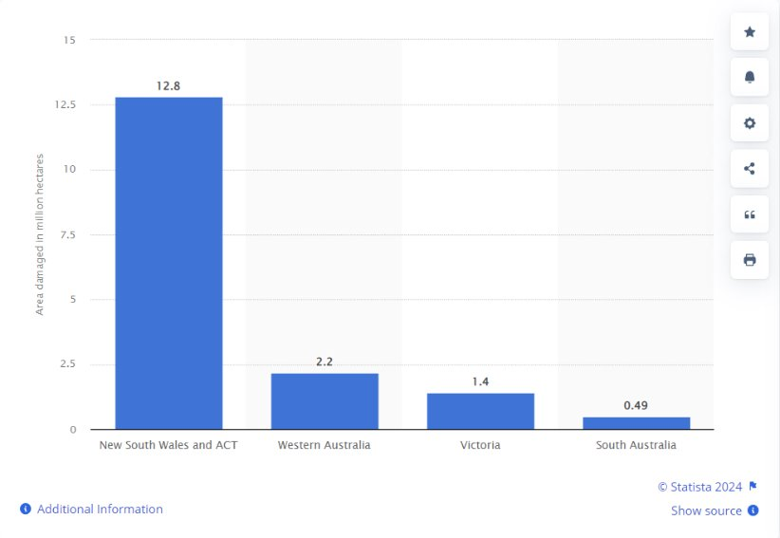

*Figure 2: Total area burned by bushfires in Australia as of January 2020, by state (in million hectares)*

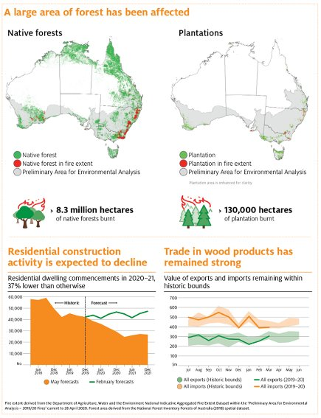

*Figure 3: Data of bushfire affected area in Australia*

# Lean Canvas

|  |  |  |  |  |  |
| --- | --- | --- | --- | --- | --- |
| Designed for: | | Designed by: | | Date: | Version: |
| Investment team |  | Blaze Battalion |  | 23/04/2024 | 2.0 |
| **Problem:**  Rural Australian areas are often ravaged by bushfires, causing damage to property, land, and the loss of human and animal life. There is a need for faster and more accurate detection systems. | | | **Solution:**  Flame Guard combines cutting-edge infrared (IR) cameras with cloud services for early fire detection. The system’s IR cameras monitor temperature changes, alerting users to potential fires before smoke or flames appear. | | |
| **Unique Value Proposition:**  Cheaper than market value with higher fire detection by about 90% and after sales support while being certified. | | | | **Customer Segments:**   * Farmers * Firefighters * People living in rural areas * Companies with facilities in bushfire prone regions | |
| **Unfair Advantage:**  Certified by Government | | **Key Metrics:**   * Accuracy * False positive rate * Detection time * Customer satisfaction | | **Channels:**  Website and SEO  Email Marketing  Social Media  Content Marketing  Paid Advertising  Trade Shows and Events  Direct Mail  Partnerships  Customer Referrals | |
| **Cost Structure:**  Labor Costs:AUD 65,000  Cost of Equipment:AUD 12,500  Operating Expenses:AUD 40,000  • Rent & Utilities: AUD 4,822.58  • Marketing & Advertising: AUD 5,866.12  • Administrative Costs: AUD 3,227.92  • Distribution & Logistics: AUD 4,370.28  • Facility Costs: AUD 1,272.21  • Technology & IT: AUD 1,441.33  • Miscellaneous Expenses: AUD 3,227.92 | | | **Revenue Structure:**  Sources of Revenue  Sales of Fire Safety Equipment  Installation Services  Maintenance and Inspection Services  Training Services  One-Time Sales  Subscription Services  Revenue Model  Combination of one-time sales and subscription services  Lifetime Value (LTV)  Depends on whether customers opt for a one-time purchase (cost of hardware + service charge + 3000 AUD) or a subscription service cost of hardware + service charge + 300 AUD * number of years of using our service)  Revenue  Total revenue is the sum of all different sources of revenue  Gross Margin  Calculated as total revenue minus the Cost of Goods Sold (COGS)  Cost of Goods Sold (COGS)  Includes cost of the fire safety systems, cost of installation, and cost of providing maintenance and inspection services (98AUD per 100sq feet + 96 AUD per hour labor cost) | | |

# Tech/Product demo

Solution

We created an environment cloud or local for using infrared cameras in farms or other rural areas in Australia. This enhanced early detection of potential fire outbreaks, reducing fire risks significantly.

By localizing areas prone to frequent bushfires and implementing our solution, which integrates real-time data analysis and predictive algorithms, we can significantly enhance the accuracy of fire detection and response measures. This can save millions of lives and protect the livelihoods of farmers and the diverse wildlife in Australia. Using Pricing Example 1 using the Product demo/prototypes such as AWS $28,147.50 ($AUD) per month Custom Moderation Adapter for 40M images per month. Or the cheaper pricing using the 2nd Pricing Example for $8,642.50 (AUD) 10M images per month to give them accessibility unless customers struggle with mortgages. To ensure everyone can access their virtual machines to have the opportunity to create suitable platforms on the Cloud to detect any nearby bushfires.

AWS Services

Some listed services may be helpful when detecting bushfires if used effectively and in a “friendly” manner.

Amazon Recognition: A deep learning-based image and video analysis service that can detect and analyze objects, scenes, and faces in images and videos. It could be used to analyze video feeds from security cameras for smoke or fire detection.

Amazon SageMaker: A fully managed machine learning service that enables developers and data scientists to build, train, and deploy machine learning models at scale. It could be used to develop custom machine-learning models for fire detection based on sensor data or images.

Amazon CloudWatch: You can monitor and observe services that provide metrics, logs, and events from AWS resources and applications. Apply real-time monitoring, which is Used to detect temperature or smoke levels that could indicate a fire.

AWS IoT Core: A managed cloud service that lets connected devices easily and securely interact with cloud applications and other devices. It could connect and manage environmental sensors and fire detection systems.

Amazon Polly: That turns text into lifelike speech, allowing applications that use audio to notify customers in a nearby fire detection.

## Issue

Our product has flaws. It has a limited field of view and is sensitive to weather conditions, which leads to occasional false alarms; we have measured up to 91% accuracy in our product prototype.

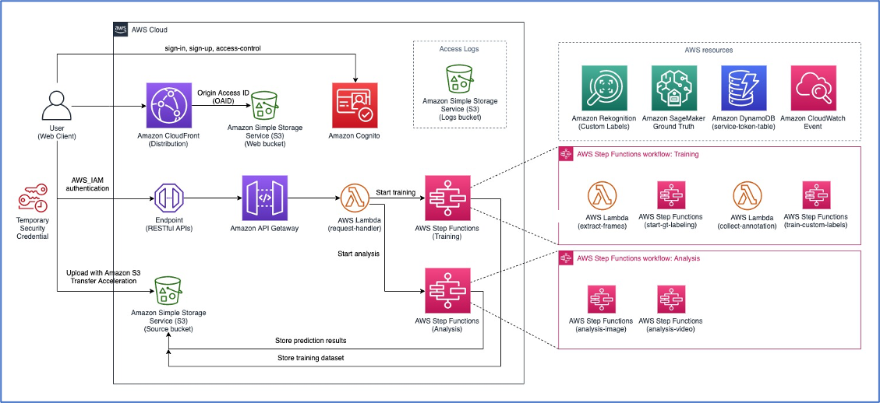

*Figure 4: An overview of the solution to build an Infrared camera detection system to alert bushfires.*

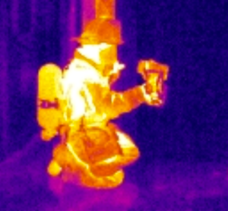

*Figure 5: An infrared image displaying a fireman holding the infrared camera.*

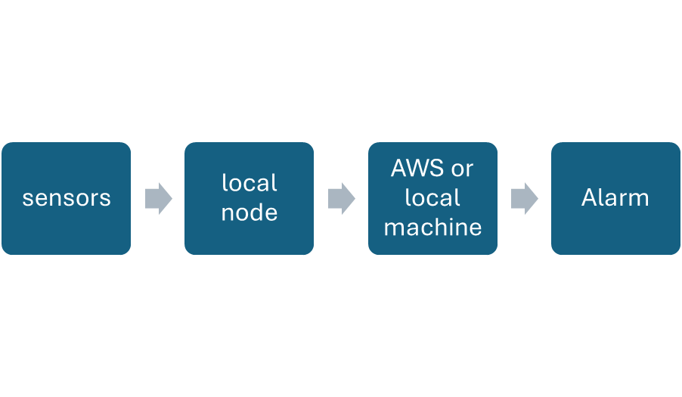

*Figure 6: A flow-procedure to trigger fire-alarms through AWS local machines.*

## Unique Value Proposition

Our product for Amazon Cloud Web based services should be reliable over competitors such as Temu, or Fluke where study shows that most infrared cameras last about 7-8 hours with a cost of $300 (AUD) and $3000 (AUD) respectively to detect smokes or fires at any time at a short range. We wanted to ensure that Amazon and non-Amazon users have access to 24/7 surveillance to reduce the retention time for the consumer to respond under pressure when encountering a nearby fire taking from any location of the world from a long distance.

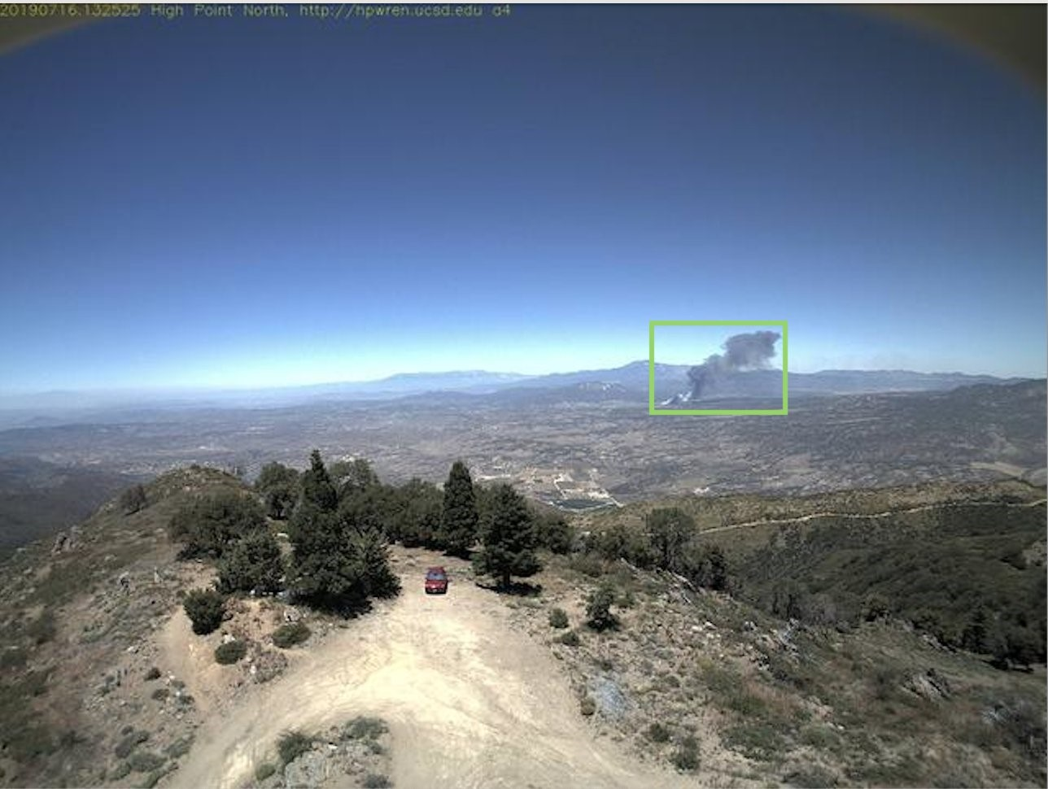

*Figure 7: Beta-testing for an infrared camera using Amazon Regokition to detect fires.*

With the advancement of artificial intelligence and machine learning is rapidly increasing soon in the future, we wanted to have infrared cameras built from Amazon implanted across all rural areas of Australia. If the Australian Government decides to spend $261 billion (AUD) to take any legal action or ask any entrepreneurs like Elon Musk or Bill Gates for a loan. To have effective use of Amazon services for all 9.3 million households according to the 2021 Census saving $2 billion (AUD) as targeted from National Bushfire Recovery Fund. We recommend to all customers and clients to use these services, able to receive multiple notifications and trigger alarm systems for smart-phone users with social communication to help and protect Australians including children and farmers anywhere to take fire protocol and pre-caution for safety measures.



*Figure 7: A prototype homepage for our product.*

# Finances

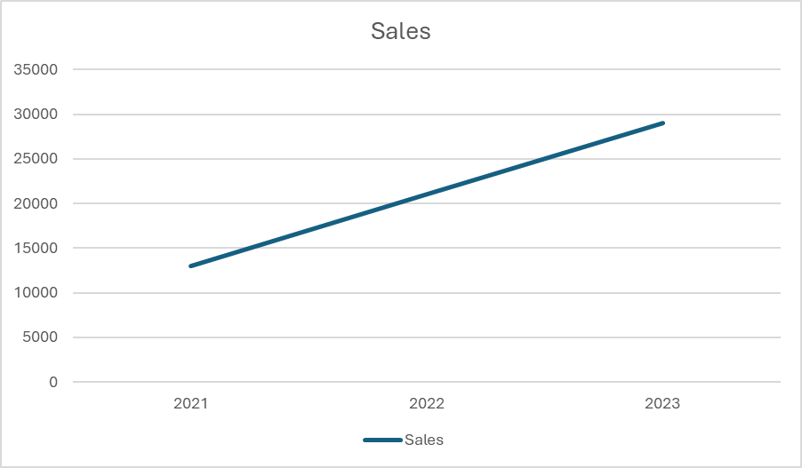

Our company has achieved remarkable success in the past quarter. Our total sales have surged to 2.5 million Australian dollars, and we are thrilled to report a substantial 66% increase in customer sales. This growth reflects our commitment to excellence and the trust our customers place in our products and services. We look forward to building on this momentum and continuing to exceed expectations.

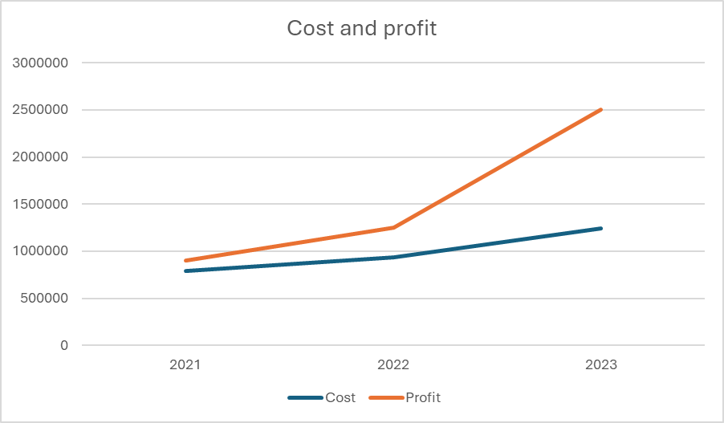

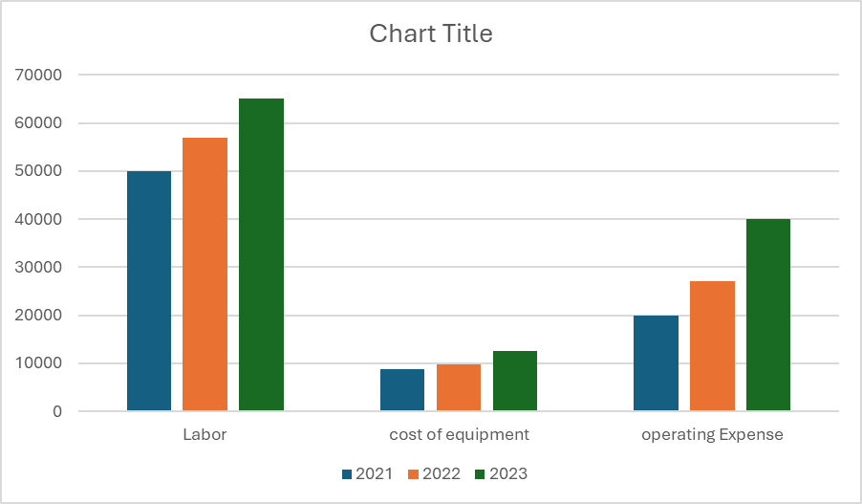

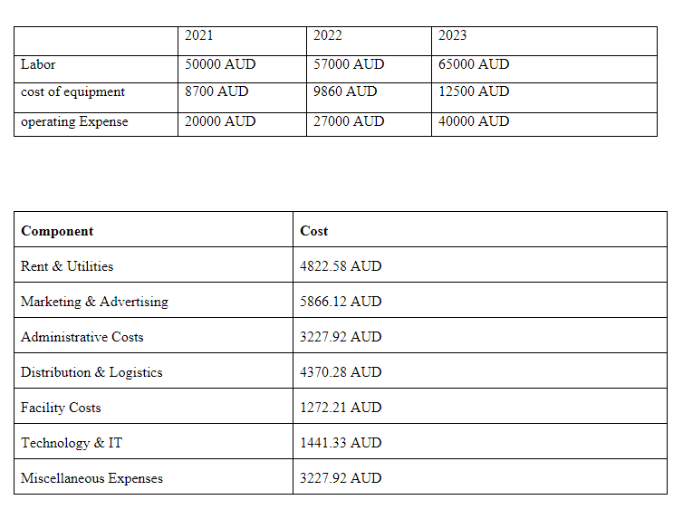

# Customer Experience Report

## Customer Profile

Occupation: Farmer

Location: Rural Area

Technology Used: Infrared Cameras and Sensors

## Problem Statement

The customer lives in a region prone to wildfires and needed a reliable, real-time fire detection system to protect their farm.

## Solution Implemented

The customer implemented a fire detection system using infrared technology. This system leverages thermal infrared cameras and sensors for early warning and monitoring of fire events.

## Customer Experience

Early Detection

The infrared system was the first to sound the alarm when a fire developed. It recognized a fire as early as the warming-up phase before fire or smoke particles developed. This early detection allowed the customer to take immediate action, potentially preventing a damaging event.

Precision and Accuracy

The infrared cameras used in the system measure particularly accurately, precisely recognize the position of the hotspot, and are designed to prevent false alarms. This precision was appreciated by the customer as it reduced unnecessary panic and allowed for targeted action.

Challenges

One challenge faced was the potential for false alarms from non-hazardous hot exhaust systems. However, the system was equipped with functions to reduce false alarms, which improved the system's reliability.

## Overall Satisfaction

The customer was satisfied with the infrared technology-based fire detection system. The early detection, precision, and reduced false alarms provided by the system were particularly appreciated. The customers felt safer and more prepared to handle potential fire incidents on their farm.

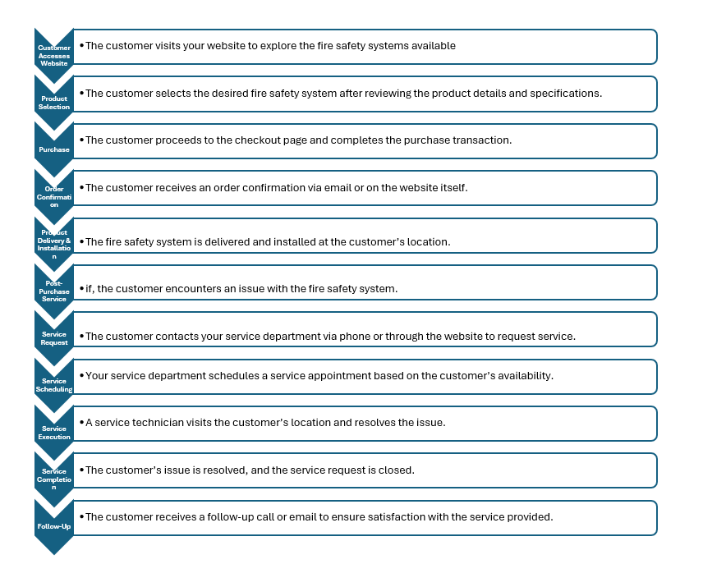

# References

[*Accuracy and Loss: Things to Know about The Top 1 and Top 5 Accuracy | by Anh T. Dang | Towards Data Science*](https://towardsdatascience.com/accuracy-and-loss-things-to-know-about-the-top-1-and-top-5-accuracy-1d6beb8f6df3)

[*World Leading Bushfire Safety Tech Installation Complete | Premier of Victoria*](https://www.premier.vic.gov.au/world-leading-bushfire-safety-tech-installation-complete)

[*Fire Drill! Thermal Cameras and Smoke | Ivy Tools Blog*](https://blog.ivytools.com/2013/05/08/fire-drill-thermal-cameras-and-smoke/)

[*Amazon Rekognition – Pricing - AWS*](https://aws.amazon.com/rekognition/pricing/?loc=ft#Free_Tier)

[*https://assets.wwf.org.au/image/upload/v1/website-media/resources/WWF_Report-Fire_on_the_Farm_converted*](https://assets.wwf.org.au/image/upload/v1/website-media/resources/WWF_Report-Fire_on_the_Farm_converted)

[*https://www.sydney.edu.au/news-opinion/news/2021/12/13/black-summer-2019-20-bushfires-cost-farmers-5-billion-australia.html*](https://www.sydney.edu.au/news-opinion/news/2021/12/13/black-summer-2019-20-bushfires-cost-farmers-5-billion-australia.html)

[*https://www.ffm.vic.gov.au/__data/assets/pdf_file/0029/526592/National-inquiry-on-bushfire-mitigation-and-management-2014.pdf*](https://www.ffm.vic.gov.au/__data/assets/pdf_file/0029/526592/National-inquiry-on-bushfire-mitigation-and-management-2014.pdf)

[*https://www.pbs.org/newshour/world/australia-to-pay-whatever-it-takes-to-fight-wildfires*](https://www.pbs.org/newshour/world/australia-to-pay-whatever-it-takes-to-fight-wildfires)

[*https://www.dailymail.co.uk/home/sitemaparchive/day_20200106.html*](https://www.dailymail.co.uk/home/sitemaparchive/day_20200106.html)

[*https://www.ffm.vic.gov.au/__data/assets/pdf_file/0029/526592/National-inquiry-on-bushfire-mitigation-and-management-2014.pdf*](https://www.ffm.vic.gov.au/__data/assets/pdf_file/0029/526592/National-inquiry-on-bushfire-mitigation-and-management-2014.pdf)

[*https://www.afac.com.au/docs/default-source/fire-and-hazard-notes/125.pdf?sfvrsn=10&download=false*](https://www.afac.com.au/docs/default-source/fire-and-hazard-notes/125.pdf?sfvrsn=10&download=false)

[*https://www.aph.gov.au/Parliamentary_Business/Committees/Senate/Finance_and_Public_Administration/Bushfirerecovery*](https://www.aph.gov.au/Parliamentary_Business/Committees/Senate/Finance_and_Public_Administration/Bushfirerecovery)

*https://csrm.cass.anu.edu.au/sites/default/files/docs/2020/9/Measuring_the_economic_impact_of_early_bushfire_detection.pdf*

[*https://www.cfs.sa.gov.au/plan-prepare/business-farms/farm-fire-safety-prevention/*](https://www.cfs.sa.gov.au/plan-prepare/business-farms/farm-fire-safety-prevention/)

*https://habitat.org.au/resilience/?gad_source=1&gclid=CjwKCAjwoPOwBhAeEiwAJuXRhx0t_2sD_JaFvSpnVJKJKTM9UDPC9cDF6-UpEALQ41iTyAiVkwXQbRoCsuUQAvD_BwE*

[*https://fireplanner.vic.gov.au/?gad_source=1&gclid=Cj0KCQjw8J6wBhDXARIsAPo7QA98gpVHiDrxBpWwHzxXZZf0mkK368ya-Srqt6m15DHytRmLUXcFlIwaAlr7EALw_wcB*](https://fireplanner.vic.gov.au/?gad_source=1&gclid=Cj0KCQjw8J6wBhDXARIsAPo7QA98gpVHiDrxBpWwHzxXZZf0mkK368ya-Srqt6m15DHytRmLUXcFlIwaAlr7EALw_wcB)

[*https://www.abc.net.au/news/2020-01-07/farmers-recount-heartbreaking-toll-of-bushfire-livestock-losses/11844696*](https://www.abc.net.au/news/2020-01-07/farmers-recount-heartbreaking-toll-of-bushfire-livestock-losses/11844696)

*Cost Benefit Analysis | The Office of Impact Analysis (pmc.gov.au)*

[*https://www.researchgate.net/publication/3420522_Arrue_BC_An_intelligent_system_for_false_alarm_reduction_in_infrared_forest-fire_detection_IEEE_Intelligent_Systems_and_their_Applications_153_64-73*](https://www.researchgate.net/publication/3420522_Arrue_BC_An_intelligent_system_for_false_alarm_reduction_in_infrared_forest-fire_detection_IEEE_Intelligent_Systems_and_their_Applications_153_64-73)

*https://www.aph.gov.au/About_Parliament/Parliamentary_departments/Parliamentary_Library/pubs/rp/rp1920/Quick_Guides/AustralianBushfires*

[*https://www.mdba.gov.au/climate-and-river-health/water-quality-threats/bushfires*](https://www.mdba.gov.au/climate-and-river-health/water-quality-threats/bushfires)

[*https://www.abc.net.au/news/science/2023-08-30/bushfires-can-be-detected-from-space-within-minutes-of-ignition/102765624*](https://www.abc.net.au/news/science/2023-08-30/bushfires-can-be-detected-from-space-within-minutes-of-ignition/102765624)

*https://aws.amazon.com/blogs/publicsector/detect-wildfire-smoke-using-amazon-rekognition/*

*https://www.temu.com/ul/kuiper/un9.html?subj=goods-un&_bg_fs=1&_p_jump_id=894&_x_vst_scene=adg&goods_id=601099512429231&sku_id=17592190687299&adg_ctx=a-254b917e~c-39339ca7~f-cbfe883e&_x_ads_sub_channel=shopping&_p_rfs=1&_x_ns_prz_type=-1&_x_ns_sku_id=17592190687299&mrk_rec=1&_x_ads_channel=google&_x_gmc_account=710728018&_x_login_type=Google&_x_ads_account=2720833615&_x_ads_set=20878039836&_x_ads_id=157413511615&_x_ads_creative_id=685403347863&_x_ns_source=g&_x_ns_gclid=Cj0KCQjw_qexBhCoARIsAFgBleuCeAygN3TGZn0pCxzSgrYip7FlvgEKvD_sBnhQs43CK990k293zXYaAiaoEALw_wcB&_x_ns_placement=&_x_ns_match_type=&_x_ns_ad_position=&_x_ns_product_id=710728018-17592190687299&_x_ns_target=&_x_ns_devicemodel=&_x_ns_wbraid=Cj4KCAjw_qexBhAVEi4A-NxB4OUMK1vh_lO9PVUlcb1kUfe6XQxkHfnEPs5d8EXH0KEAwgm0EM5YU5JGGgIupw&_x_ns_gbraid=0AAAAAo4mICEhe3aIB-ZbqsOJYas7zLlFk&_x_ns_targetid=pla-2087129004693&gad_source=1&gclid=Cj0KCQjw_qexBhCoARIsAFgBleuCeAygN3TGZn0pCxzSgrYip7FlvgEKvD_sBnhQs43CK990k293zXYaAiaoEALw_wcB*

*https://www.fluke.com/en-au/products/thermal-cameras*

*https://www.dcceew.gov.au/environment/biodiversity/bushfire-recovery/activities-and-outcomes*

*https://aifs.gov.au/research/facts-and-figures/population-households-and-families#:~:text=With%20the%20population%20growth%2C%20the,9.275%20million%20households%20in%20Australia.*